HOSPITAL MANAGEMENT SYSTEM

Software Requirements Specifications
Version 1.0

JUNE 2008



Software Requirements Specifications of the
Hospital Management System

BATCH-1 TG-1

- Amithkumar Jha(246262 )
- Jayasubbareddy(246234)
- Jayalakshmi (246417 )
- Rajeshwaran(246361)

TABLE OF CONTENTS
1. INTRODUCTION
1.1Purpose…………………………………………………………………………………..5
1.2 Intended users………………………………………………………………………… 5
1.3 Scope…………………………………………………………………………………… 5
1.4 Definitions, Acronyms and Abbreviations ……………………………………………..6
1.5 Document overview…………………………………………………………………… 7
2. GENERAL CHARACTERISTICS……………………….……………………………………7
2.1Introduction
2.2 Product perspective…………………………………………………………………….8
2.2.1 System Interfaces………………………………………………………………9
2.2.2 User Interfaces…………………………………………………………..……10
2.2.3 Hardware Interfaces…………………………………………………..………11
2.2.4 Software Interfaces…………………………………………………..……….12
2.2.5 Communications Interfaces………………………………………..…………12
2.2.6 Site adaptation requirements……………………………………..…………..12
2.3 User Characteristics………………………………….…………………...…………..13
3. SPECIFIC REQUIREMENTS……………………...…….…………………………….…….14
3.1 External Interface Requirements…………….………………………………………...14
3.2 Functional Requirements…………………….………………………………………...14
3.3 Detail Description of Functional Requirements
3.3.1 Make Appointment…..……………….… ……………………..……………...14
3.3.2 Cancel Appointment…………………………………………………………...15
3.3.3 Upgrade Patient Record……..............................................................................15
3.3.4 Maintain Doctor Record…………….…….…..………….…………………....16
3.3.5 Generate Record….……….…………………..………....………………….…16
3.3.6 Prescribe Medicine…………………………….…….………………………...16
3.3.7 Billing……………………………………………....……………………….…17
3.4 Nonfunctional Requirements……………………………………………………… . ..26
3.4.1 Security…………………………………………………………………………21
3.4.2 User friendly….…..……………………………….……………………………22
4. OTHER REQUIREMENTS………………………………..………….………………………30
4.1 Generic Requirements………………………………..……….………………. ……..30
5. USE CASE DIAGRAM
5.1 Use Case Diagram (User’s Perspective) ……………………….……………………..30
6. CLASS DIAGRAM……………………………………………………………………………..31
7. SEQUENCE DIAGRAM……………………………………………………………………….32
8. GLOSSARY OF TERMS……….…………………………………….………………………..41

1 Introduction

  - Purpose
The purpose of this document is to give a precise and comprehensive view of the software requirements as well as lay down the guidelines necessary for the development and maintenance of hospital management system. The software is developed to load the details in hospital database in a systematic and methodical manner. This document will satisfy the functional performance, design and verification requirements for the computer software (HOSPITAL management system). This document is intended to be a baseline and a reference work to supply sufficient design information to the users, as a foundation for software assessment and approval.

  - Intended Users
This document is intended for use by the designers of this automated system and for those who may be required to maintain it. The document will enable them to understand all aspects of the system in detail. The intended user for this software is the doctor, receptionist, administrator, and cashier. It will enable the hospital staff to know all the requirements necessary to load and validate the route details.

  - Scope

This document describes the software requirements of the HOSPITAL MANAGEMENT SYSTEM in accordance with the product specifications stated in the “System Requirements Specifications” document. The deliverable product will be referred to as HOSPITAL MANAGEMENT SYSTEM and will be a package that includes the following:

- Software System: This software will act as an interface to hospital staff. The software will accept the information from the users (hospital staff). It will be capable in identifying the Service, routing regions, ports and route details. The software will upload and validate the details from the database and a report will be generated. The software will control the operation of the interface and the users can update any information into the database, and maintain a record of all the services performed.

- Software documentation: Complete and easy-to- understand documentation of the software will be provided to aid in future maintenance and/or modification of the software.
- Operations Manual: An operations manual will be provided with the software which will explain in detail the operation and maintenance.
This SRS is intended to produce software to be called the” Hospital management system”. The software will provide hospital staff the capability to maintain patient records, make appointment, cancel appointment, maintain doctor record etc…. A receptionist maintains the records of patient to make or cancel appointment according to the availability of doctor and upgrade the patient record. The doctor prescribes medicines to patient and administrator generates reports on appointment vs. no. of visits .The cashier check for the hospital service rates and makes billing.

1.4 Definitions, Acronyms and Abbreviations
Abbreviation/Acronym | Description
Patient | One consults the doctor for medication.
Doctor | An employee of hospital who checks the condition of patient and prescribes medication.
Receptionist | One who makes or cancels appointment of patient based on request and availability of doctor. Generate reports, bills and keeps track of no. of appointments and no. of visits made by patient.
User ID or Username | Unique Identification of User
Password | Used to authenticate the user
Bill | Charges imposed on the patient for the services availed from hospital.
Prescription | Slip which contains medication details.
Report | This contains no. of visits and no. of appointments made by the patient.

  - Document overview

This document has three major sections.
1. Section 1 provides an overview of the entire SRS document.
It includes:
- purpose
- Intended users
- Product scope

2. Section 2 describes the general characteristics of the product that will be produced.
It includes:
- Introduction
- Product perspective
- System Interface
- User Interface
- Hardware Interface
- Software Interface
- Communication Interface
- Site Adaptation Requirements

3. Section 3 addresses the specific requirements of the feedback automation.
It includes:
- External interface requirements
- Functional requirements
- Non Functional requirements
- Other requirements

2. General Characteristics

2.1 Introduction

This section introduces that software product. It describes the characteristics and limits affecting the product and its requirements. Only the authorized users (Doctor, Receptionist, and Patient) will be able to use the system.

2.2 Product perspective

The application will be a windows-based, secured, user friendly, self contained and independent software product.

2.2.1 System Interfaces

2.2.1.1 Receptionist to Portal
- Maintain patient details.
- Maintain Doctor Details like availability, doctor timing etc.
- Upgrade details.
- Check Registration.
- Make Appointment.
- Cancel Appointment
- Maintain Prescription
- Maintain billing details.
- Generate report to patient.
2.2.1.2. Doctor to Portal
1). Upgrade his details whenever needed (like time of availability).
2). Maintain Prescription Detail

2.2.2 User Interfaces
2.2.2.1 The User will start the homepage with the following options:
- Home
- Login
Depending upon the selection the next page would be displayed.
The login page has three fields
- Receptionist Login
- Doctor Login
- Patient Login
Depending upon the field in the database corresponding to login and password, three different pages will be displayed-------
1. WELCOME RECEPTIONIST
2. WELCOME DOCTOR
3. WELCOME PATIENT
4. WELCOME CASHIER

2.2.2.2 Receptionist will be available with following options.
- View Patient Name
- View Patient Address
- View Patient Gender
- View Patient Phone number
2.2.2.3 Make Appointment of Patient will be available with following options.
- View Patient Name
- View Date
- View Purpose
- View Time
      - Make Appointment to Patient page will be available with following options.
- Patient Name
- Date
- Purpose
- Time

      - Cancel Appointment of Patient page will be available with following options
- Patient Name
- Appointment number
      - Maintain(Add)Doctor will be available with following options
- Doctor ID
- Doctor Name
- Specialization
- Gender
- Age
- Address
- Contact number

2.2.3 Hardware Interfaces

Machine | Intel Pentium IV or equivalent / AMD processor
RAM | 512 MB
Hard disk | 20 GB
Resolution | 800/600

2.2.4 Software Interfaces
- Any Windows based operating system(Windows 9X/XP/NT)
- Oracle 9i as the DBMS
- Eclipse 3.1 for coding and developing the software
- J2EE, Java Scripting

Software mentioned in points 2 and 3 in the software interfaces above will be required only for the development of application. The final application will be packaged as an independent setup program that will be delivered to the client.

2.2.5 Communications Interfaces
The medium of communication for the portal is Intranet/Internet. It would depend on internet protocols to maintain proper communication interface. The protocol proposed for usage in the portal is HTTP. This would be used for sending and receiving requests and response.

2.2.6 Site adaptation requirements
Hardware and Software interfaces support is required at the user side.

2.3 USER CHARACTERISTICS

This software will be used by four kinds of users. They are Receptionist, Doctor and Patient. The various functions that can be performed by users are indicated in section 3, functional requirements. Each user will have access to the system only through user-id and password mechanism.

3. Specific Requirements

3.1 External Interface Requirements
Input from the user will be via keyboard input and mouse point and click. The user will navigate through the software by clicking on icons and links. The icons will give appropriate responses to the given input
3.2 Functional Requirements
This section organized in sub-sections contains the details necessary for the system engineer to create the design specifications of the HOSPITAL MANAGEMENT SYSTEM.

3.3 Detailed Description of Functional Requirements
This section provides a requirement overview of the product. The project will be on J2EE and the backend will be Oracle.
The requirements are described below:
The user will be able to search a patient either by his name or patient Id. If the search result yields more than one patient’s data, then information (already stored in the database through Admission module) of all those patients will be displayed. The user then will be able to select the particular patient he is looking for.

The information that is to be displayed automatically is:
- The patient name
- Patient Id
- Gender (M/F)
- Patient Address
- Patient Contact no.
- Patient Age

Following functionality will be present:
1. The billing information includes the bill for each type of service. A patient’s total bill should be shown in slabs:
The slabs are:

Hospital Service |  | Prescription Charges |  | Appointment Charges
1) Bill for consultation |  | 1) Pharmacy bill |  | 1) Consultation Fee
2) Bill for Laboratory Tests or Investigations (e.g. X-ray, CT-scan) |  | 2)Appointment Charges |  | 2) Medicine Bill
3) Bill for Bed Allocation & Food |  | 3) Total Bill |  | ---------

- In case of Hospital services, there will be an interface for the user to input the name of the services and its cost. Hospital services can include services by department (e.g. room rent, food).
- In the case of Laboratory Tests, there will be an interface to input the name of the tests available. All the available tests will be displayed with checkboxes in the laboratory services form. The user will select the tests done by a particular patient. In the final billing report, only the selected tests will be displayed with corresponding cost.

- The Total amount to be paid by the patient will be displayed at the bottom of the final bill.

3.3.1 MAKE APPOINTMENT:
FOR->PATIENT
3.3.1.1: INTRODUCTION:
1. Patient requests receptionist to “Make an Appointment”. Then the receptionist enters the patient details. If the patient is not already registered then he is registered. The receptionist validates details and checks for availability of the doctor. The Hospital management system is first providing an option for entering ID and unique password for doctor, receptionist, administrator, and cashier for security purpose. The system has password changing options also.
2. The system gets this login details from user interface and verifies and validates (from database) whether the user is valid or not.
3. The user must have a valid Id.
4. If user is valid, the user will get access to the system, otherwise the system tells the user to reenter user ID and password. If user enters incorrect password, the system tells him to enter correct password.
5. If user ID and password are valid, then main form should be displayed.
3.3.1.2: INPUTS:
- Patient Id
- Patient Name
- Patient Gender
- Patient Age
- Patient Address
- Patient Contact Number
- Date of appointment
3.3.1.3: PROCESSING:

MAKE APPOINTMENT UPON REQUEST OF PATIENT:

Enter the Patient Id
Check for Registration
If not registered
Then register the new patient
Enter the date & time of appointment
Check for availability of doctor
If available
Then update appointment data
Else
Suspend process

3.3.1.4 OUTPUT:
1. Prompt to enter details.
2. Message Displaying Pid, Did, Date, time.
3.3.2 CANCEL APPOINTMENT:
By->RECEPTIONIST
3.3.2.1: INTRODUCTION:
- A Patient who had already made an appointment requests the receptionist to cancel the appointment.
- Then the patient details and appointment details are entered.
- Then the receptionist cancels the appointment.
3.3.2.2: INPUTS:
- Patient Id
- Date and Time of appointment.
3.3.2.3 PROCESSING:
CANCEL APPOINTMENT UPON REQUEST OF PATIENT:
Enter P_ID, Date and Time of appointment
If the P_ID is on the appointment list for the date
Then cancel the appointment
Change the status of the doctor as available for that date & time
Else
Suspend the process

3.3.2.4 OUTPUTS:
- Displays message that the appointment for the PID on date & time is cancelled.

3.3.3 MAINTAIN DOCTOR RECORD:

By->RECEPTIONIST
3.3.3.1: INTRODUCTION:

- The records of all the doctors of the hospital are stored in a database.
- The receptionist maintains (add, delete, modify) the records of all the doctors of the hospital in a database.
3.3.3.2: INPUTS:

- Doctor Id (did)
- Doctor Name
- Doctor Date of joining
- Doctor Age
- Doctor Gender
- Doctor Contact Number
3.3.3.3: PROCESSING:

- Entering the doctor details.

3.3.4 GENERATE REPORT:

By->RECEPTIONIST

3.3.4.1: INTRODUCTION:

- The Receptionist checks for the no. of appointments no. of visits made by the patient and then generate report.
3.3.4.2: INPUTS:

1. List of appointment made.
2. List of prescription generated.
3.3.4.3: PROCESSING:

- Check the appointment made from the appointment class.
- Count no. appointments made.
- Check the no. of prescriptions generated from the prescription class.
- Count the no. of prescriptions generated.
- Update the reports.
- Generate the report.
3.3.4.4: OUTPUTS:

- A message is displayed saying report generated.
- A message is displayed saying report database generated.

3.3.5 PRESCRIBE MEDICINES:

By->DOCTOR
3.3.5.1: INTRODUCTION:

The patient consults the doctor. The doctor enters the patient id (pid) and then checks the patient record. Then he issues the prescription.
3.3.5.2: INPUTS:
1. Patient Id
2. Prescription.
3.3.5.3: PROCESSING:

1. Enter the patient id.
- Check the patient prescription.
- Issues prescription.
- Update prescription
3.3.5.4: OUTPUTS:

1 .A message is displayed stating that prescription is generated.

3.3.6: BILLING:

By->RECEPTIONIST
3.3.6.1: INTRODUCTION:

- The Receptionist checks for the hospital services, lab services availed by the patient, and generates bill accordingly.
3.3.6.2: INPUTS:

- Patient Id .
- Date.
- Appointment Charges.
- Prescription Charges.
- Hospital Charges.
- Total Charges.
3.3.6.3: PROCESSING:

1. Enter the patient id.
2. Check the patient prescription.
- Generate report of Appointment, Prescription, Hospital charges.
- Issues total billing.
3.3.6.4: OUTPUTS:

1 .A message is displayed stating that bill is generated.
3.4 Nonfunctional Requirements:

3.4.1 Security: - Security for the users (hospital staff) is ensured by providing unique ID to them. Unauthorized users can not access the details of Hospital Management System.

3.4.2 User friendly: - System is designed with GUI screens for user friendliness.

4. Other Requirements

4.1 Generic Requirements

User’s interaction with the system is manual in the current version of hospital management system and it includes normalized tables.

NORMALISED TABLES:

PATIENT

FIELD NAME | TYPE(SIZE) | NULL/NOT NULL | PRIMARY/FOREIGN KEY
PATIENT_ID | NUMBER(10) | NOT NULL | PRIMARY KEY
PATIENT_NAME | VARCHAR2(25) | NOT NULL | NONE
PATIENT_ADDRESS | VARCHAR2(80) | NOT NULL | NONE
PATIENT_PHONE | VARCHAR2(12) | NOT NULL | NONE
PATIENT_GENDER | VARCHAR2(1) | NOT NULL | NONE
PATIENT_AGE | NUMBER(3) | NOT NULL | NONE

DOCTOR

FIELD NAME | TYPE(SIZE) | NULL/NOT NULL | PRIMARY/FOREIGN KEY
DOC_ID | NUMBER(10) | NOT NULL | PRIMARY KEY
DOC_NAME | VARCHAR2(25) | NOT NULL | NONE
DOCR_ADDRESS | VARCHAR2(80) | NOT NULL | NONE
DOC_DEGREE | VARCHAR2(15) | NOT NULL | NONE
DOC_CONTACTNO | VARCHAR2(12) | NOT NULL | NONE
DOC_SPECIALIZATION | VARCHAR2(50) | NOT NULL | NONE

LAB TECHNICIAN

FIELD NAME | TYPE(SIZE) | NULL/NOT NULL | PRIMARY/FOREIGN KEY
TECH_ID | VARCHAR2(10) | NOT NULL | PRIMARY KEY
TECH_NAME | VARCHAR2(25) | NOT NULL | NONE
TECH_ADDRESS | VARCHAR2(80) | NOT NULL | NONE
TECH_DEGREE | VARCHAR2(15) | NOT NULL | NONE
TECH_SPEC. | VARCHAR2(15) | NOT NULL | NONE

PRESCRIPTION

FIELD NAME | TYPE(SIZE) | NULL/NOT NULL | PRIMARY/FOREIGN KEY
PATIENT_ID | VARCHAR2(15) | NOT NULL | PRIMARY KEY
PATIENT_NAME | VARCHAR2(25) | NOT NULL | FOREIGN KEY
PROBLEM_TYPE | VARCHAR2(10) | NOT NULL | NONE
DESCRIPTION | VARCHAR2(30) | NOT NULL | NONE

APPOINTMENT

FIELD NAME | TYPE(SIZE) | NULL/NOT NULL | PRIMARY/FOREIGN KEY
APP_ID | VARCHAR2(15) | NOT NULL | PRIMARY KEY
PATIENT_ID | VARCHAR2(15) | NOT NULL | FOREIGN KEY
APP_DATE | DATE | NOT NULL | NONE
APP_TIME | NUMBER(8) | NOT NULL | NONE
PURPOSE | NUMBER(15) | NOT NULL | FOREIGN KEY
DOC_ID | NUMBER(10) | NOTNULL | FOREIGN KEY

BILL

FIELD NAME | TYPE(SIZE) | NULL/NOT NULL | PRIMARY/FOREIGN KEY
BILL_NO | NUMBER(10) | NOT NULL | PRIMARY KEY
PATIENT_ID | VARCHAR2(15) | NOT NULL | FOREIGN KEY
BILL_DATE | DATE | NOT NULL | NONE
DRUG_NAME | VARCHAR2(15) | NOT NULL | NONE
DRUG_PRICE | NUMBER(5,2) | NOT NULL | NONE
TOT_AMT | NUMBER(7,2) | NOT NULL | NONE

LAB REPORTS

FIELD NAME | TYPE(SIZE) | NULL/NOT NULL | PRIMARY/FORIGN KEY
REPORT_ID | VARCHAR2(15) | NOT NULL | PRIMARY KEY
REG_ID | VARCHAR2(15) | NOT NULL | FOREIGN KEY
TECH_NAME | VARCHAR2(25) | NOT NULL | FOREIGN KEY
DATE | DATE | NOT NULL | NONE
DOC_NAME | VARCHAR2(25) | NOT NULL | FOREIGN KEY
DISEASE_NAME | VARCHAR2(10) | NOT NULL | NONE
RESULT | VARCHAR2(10) | NOT NULL | NONE

5. Use Case Diagram

5.1. USE CASE DIAGRAM (USER’S PERSPECTIVE)

HOSPITAL MANAGEMENT SYSTEM

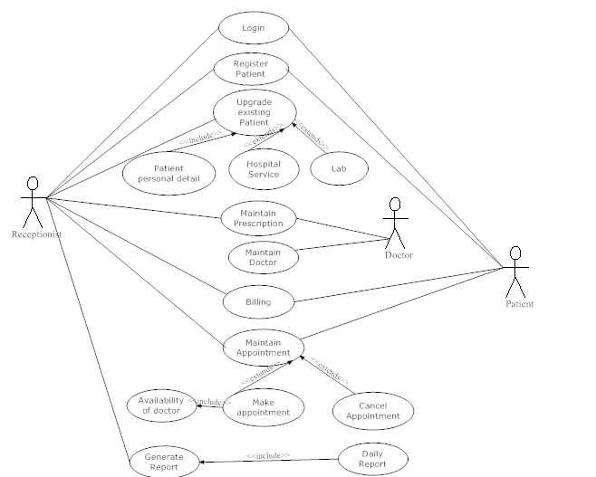

Batch Dosier

- CLASS DIAGRAM:

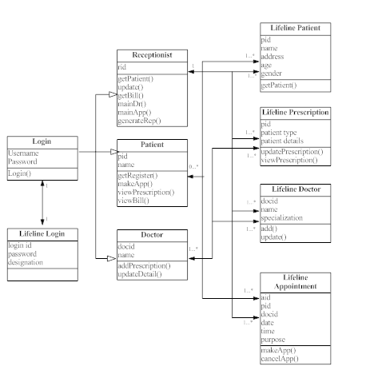

7.SEQUENCEDIAGRAMS:

Login
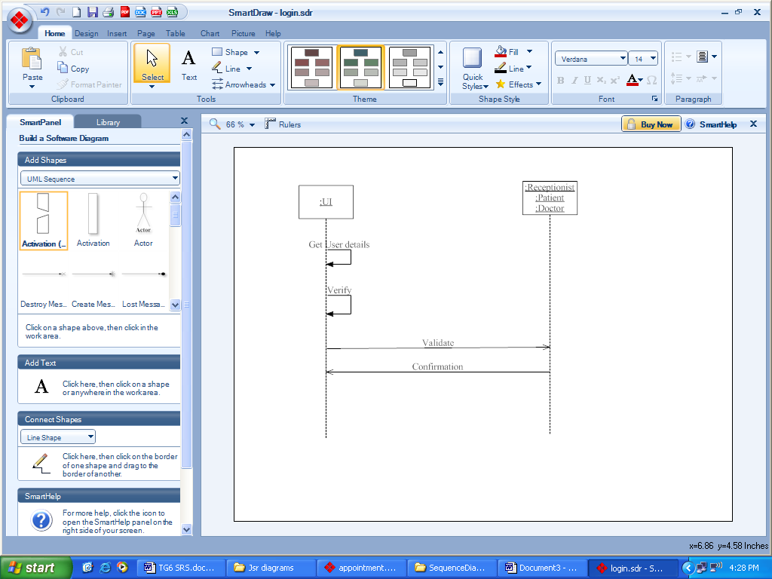

Register

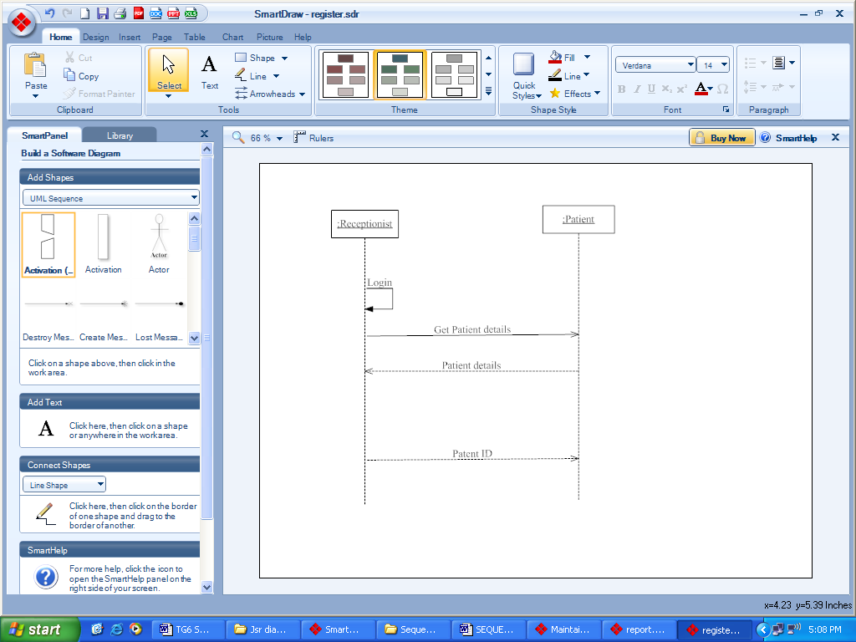

Upgrade Existing Patient Details

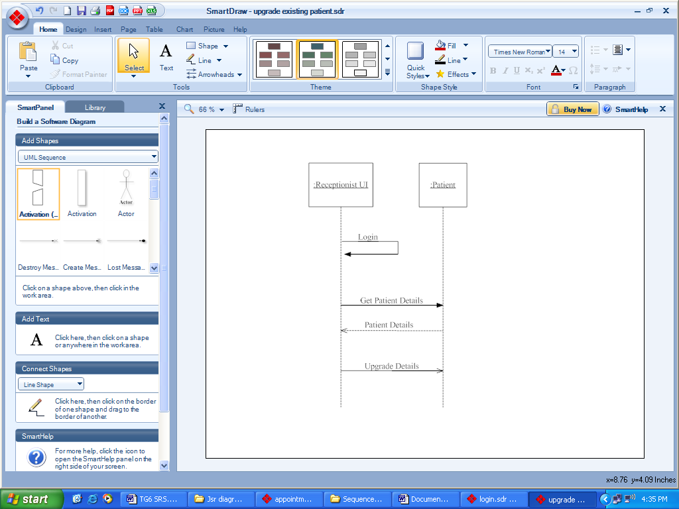

Appointment

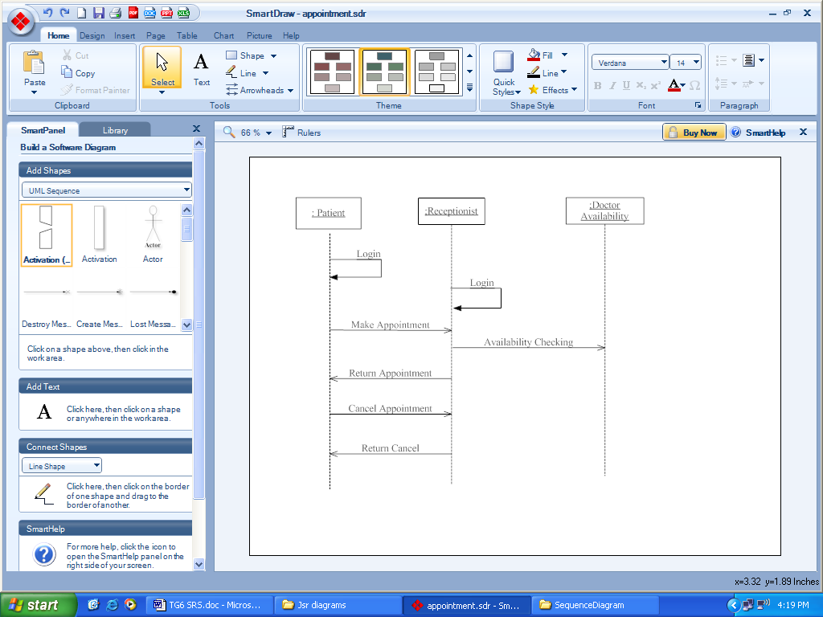

Billing

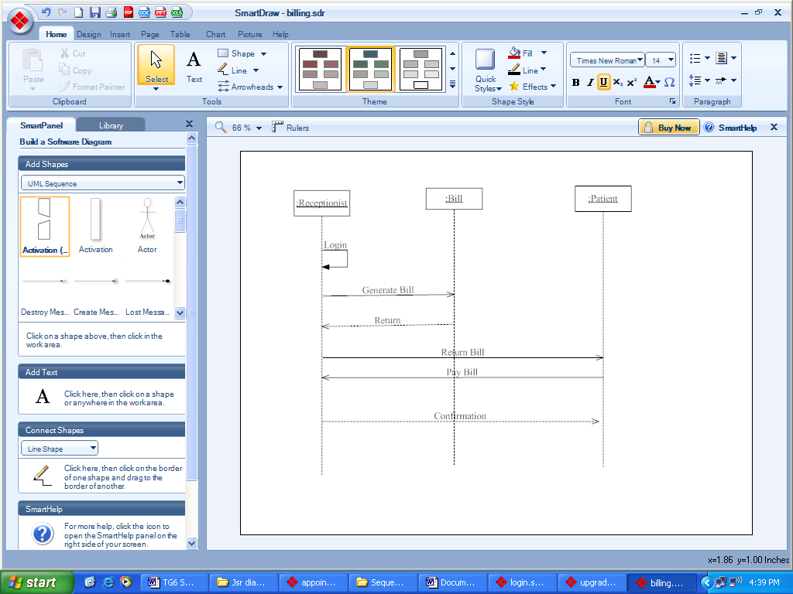

Maintain Doctor

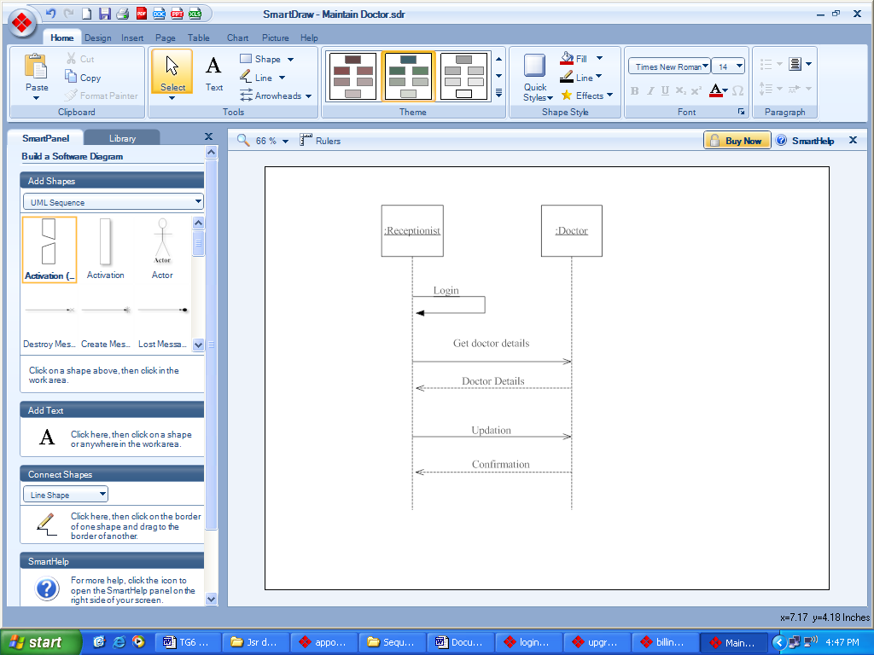

Maintain Prescription

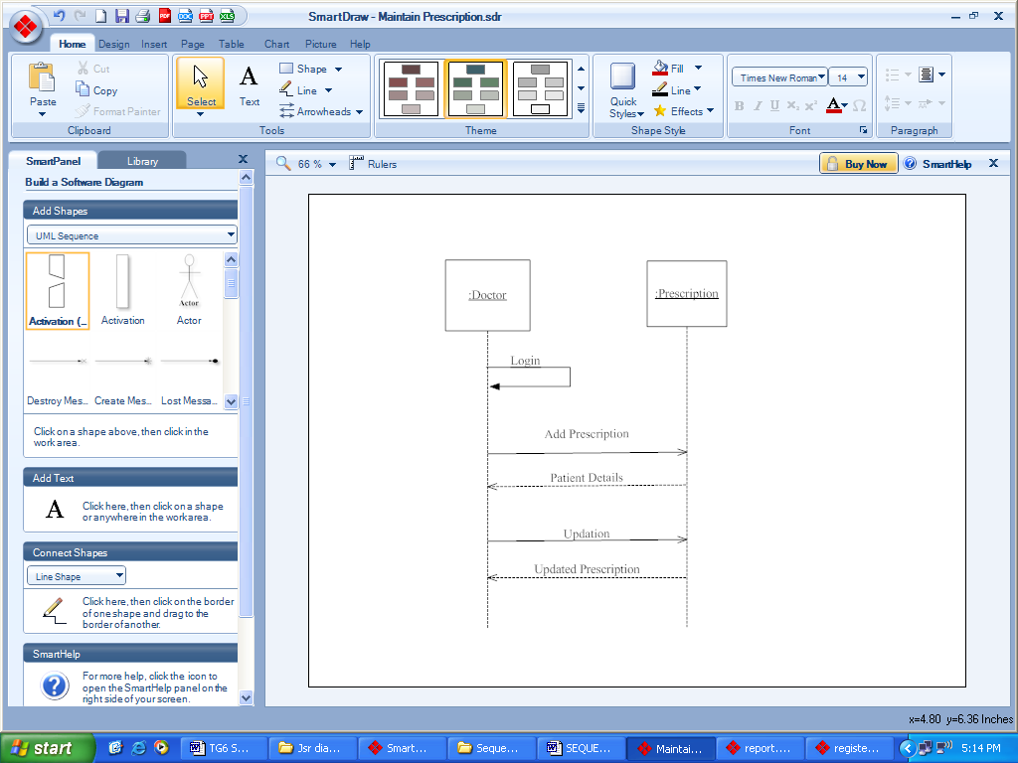

Report

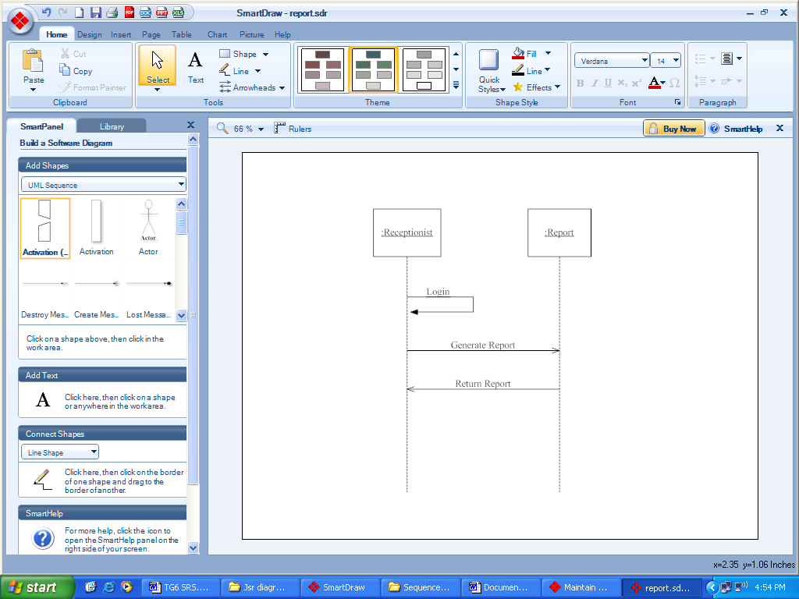

8. GLOSAARY OF WORDS

Acronyms and Abbreviations

Abbreviation/Acronym | Description
User ID  User  User ID  Password  Session | Unique Identification for patient.  User is the person who is authorized to access the system for performing various functionalities.  User identification of user. The users include Receptionist, Doctor, Administrator and Cashier.  Used to authenticate the users of the system.  Use to keep track of name and designation between the user login and user log.

